Full paper title

Name Surname1, Name Surname2 and Name Surname3 [1]

**Abstract**

The abstract is a mandatory element that should summarise the paper’s content in **300 to 500** words. Please use the Aptos style in an 11-point font for the abstract. Avoid citing sources in your abstract. The abstract should be self-contained and fully understandable without referencing external materials.

**Keywords**: Please list your keywords here. They should be separated by middots, if possible. The first letter of each keyword should be capitalized.

# Introduction

Full papers proposed for the Springer Nature book should be between **6,000 and 7,000 words**, including references. Use APA7 style for references.

A paper should contain the description of your study and should follow the general structure of Abstract, Introduction, Methodology, Results, Conclusions, Acknowledgements (if applicable) and References.

For the main text, please use the Aptos style in a 12-point font, justify the text, and apply 12 pt spacing before and after paragraphs.

# Methodology

Clearly explain the research methodology in this section.

## Heading

All figures and other graphics should be embedded within the text immediately after their first mention (Fig. 1). Preferably use the colour palette black, grey and white.

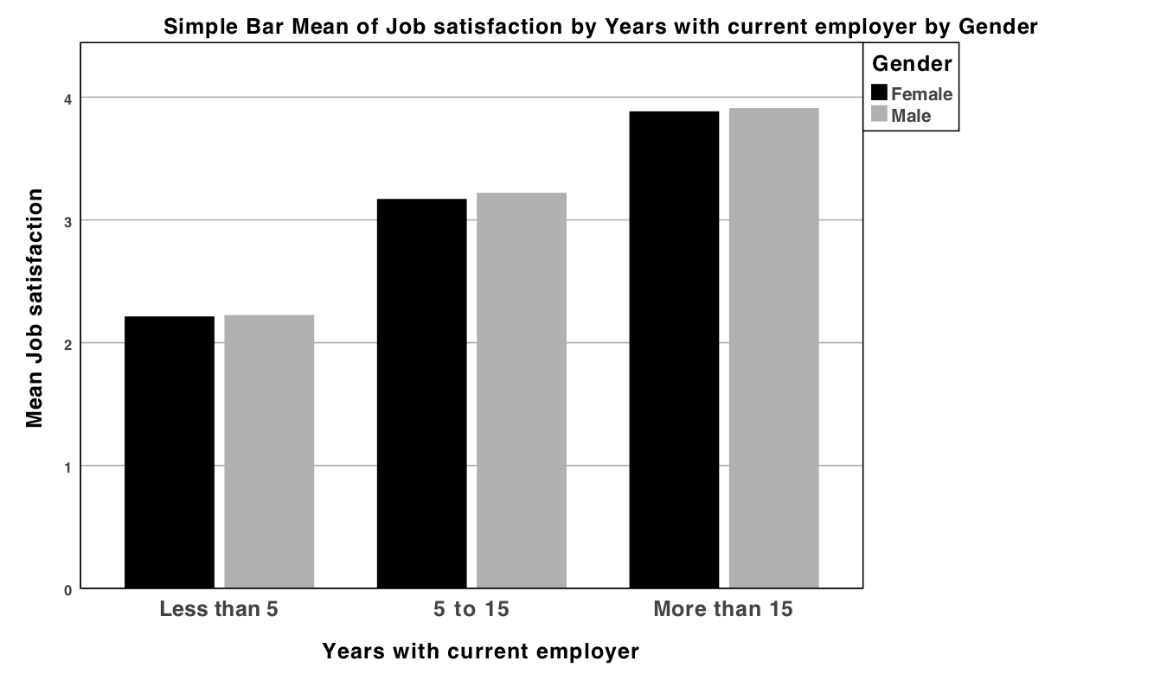

**Fig. 1.** Example of figure (Source: author, year)

## Heading

Tables must be created using Microsoft Word’s table functions and included in the text immediately after their first mention (Table 1). Do not place them at the end of your paper. For improved readability, keep your tables as simple as possible. Preferably use the colour palette black, grey and white.

**Table 1**. Table header

|  |  |  |
| --- | --- | --- |
| Topic | Topic | Topic |
| A | 200 | 20% |
| B | 300 | 30% |
| C | 250 | 25% |
| D | 250 | 25% |

# Results

Present and discuss the main results of the work. Tables and figures may be used to support your discussion.

# Conclusion

Provide a brief conclusion that includes a summary and generalisation of your results, as well as the contributions and limitations of your work.

# Acknowledgements

This section is optional. Acknowledgement can be included identifying the funding sources.

# Use of AI tools declaration

Please provide a statement as to whether and how artificial intelligence has been used in the text. Please refer to Springer Nature's editorial policy on artificial intelligence (<https://www.springernature.com/gp/policies/editorial-policies>).

# References

Follow APA style 7th edition.

Aleixo, A., Azeiteiro, U., & Leal, S. (2017). UN Decade of Education for Sustainable Development: Perceptions of higher education institution’s stakeholders. In W. Leal Filho, U. Azeiteiro, F. Alves, & P. Molthan-Hill (Eds.), Handbook of theory and practice of sustainable development in higher education – volume 4 (pp. 417–428). Springer.

Leal Filho, W. (Ed.). (2017). Climate change research at universities: Addressing the mitigation and adaptation challenges. Springer. <https://doi.org/10.1007/978-3-319-58214-6>

Leal Filho, W., Begum, H., Anholon, R., Quelhas, O., Rampasso, I., Sharifi, A., De Andrade Guerra, J., Gatto, A., Lovett, M., Velazquez, L., Chávez Muñoz, P., Alam, A., Brandli, L., Salvia, A. L., Amaro, N., & Eustachio, J. (2024). Addressing the challenges posed by energy poverty in Latin American countries. Discover Sustainability, 5(1). <https://doi.org/10.1007/s43621-024-00426-9>

Leal Filho, W., Sigahi, T., Anholon, R., Rampasso, I., Platje, J., Velazquez, L., & Salvia, A. (2024). Sustainable innovation: Case studies from product development. Sustainable Development. <https://doi.org/10.1002/sd.3269>

1. N. Surname1

   Author affiliation, Town/City, Country

   [author1email@email.xx](mailto:author1email@email.xx)

   N. Surname2

   Author affiliation, Town/City, Country

   [author2email@email.xx](mailto:author2email@email.xx)

   N. Surname3

   Author affiliation, Town/City, Country

   [author3email@email.xx](mailto:author3email@email.xx)

  